PS 13 – Implement the Kalman filter
Write MATLAB code to implement the Kalman filter to estimate the unknown states of the following (unknown) state-space system:
𝑦𝑦 = [1 0]𝑥𝑥
−2 −1 1 𝑥𝑥̇ = 𝑥𝑥 + 𝑢𝑢
−2 −3 1
where the true (but unknown) input is
𝑢𝑢 = 4 𝑠𝑠𝑠𝑠𝑠𝑠(3𝑡𝑡).
A measurement um of the input u is known, but noisy according to the following equation:
𝑢𝑢_{𝑚𝑚} = 𝑢𝑢 + 𝑣𝑣
where 𝑣𝑣 is zero-mean Gaussian noise with a standard deviation of 0.5. A measurement of the output 𝑦𝑦 is known, but noisy. It is corrupted by zero-mean Gaussian noise with a standard deviation of 0.1.
The true (but unknown) initial state is
3
𝑥𝑥 = −2
The known but inaccurate model of the state-space system is
𝑦𝑦_{𝑝𝑝} = [1 0]𝑥𝑥
−2.1 −0.9 1.1
𝑥𝑥̇ = 𝑥𝑥 + 𝑢𝑢. −1.2 −2.8 0.9

Code a Kalman filter in MATLAB to estimate the state-trajectory and graph the estimated states on the same plot as the true, but unknown, states. Since the true initial condition is unknown, assume zero initial conditions. Use the identity matrix as the initial condition for the state-covariance matrix. For the Kalman filter tuning matrices, use
0.02 0
𝑄𝑄 =
0 0.02
𝑅𝑅 = 0.3

- Submit your plot and corresponding script (*.m) file.

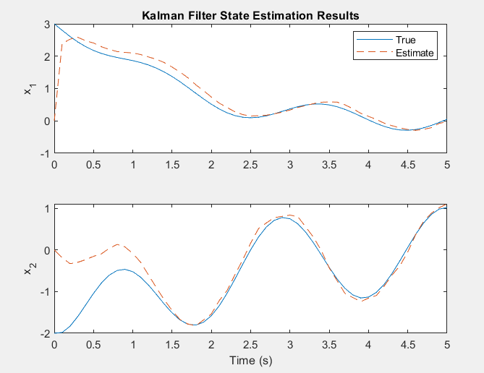

- Experiment with different noise models corrupting the output measurement 𝑦𝑦 and input 𝑢𝑢_{𝑚𝑚} as well as changes in the known but inaccurate model of the state-space system. What do you observe and learn?

I have noticed that the larger the value of R, the longer the filter takes to correct the estimate to the true value. I have also noticed that the lower the values of the diagonal QQ matrix, the less oscillation there in the error correction.

